Development of the Liver

Origin of the Hepatic Primordium
- Day 22: liver primordium first appears at the superior intestinal portal, caudal and ventral to the heart
- Around the middle of the 3rd week / beginning of the 4th week: the liver bud, gallbladder, and biliary duct arise as a ventral outgrowth from the distal foregut
- The hepatic diverticulum grows into the transverse septum — a mesodermal structure between the pericardial cavity and the yolk sac stalk, containing the vitelline and umbilical veins

Invasion Pattern — Unique to Humans
- In humans, endodermal invasion is not by cords of cells (as in most animals) but by migration of individual endoderm cells
- These cells do not maintain contact with each other — they mingle freely with mesenchymal cells of the transverse septum
- This individual cell migration pattern means early human hepatogenesis is more dispersed and interactive with the mesenchyme
[TIP]Human-specific: A higher proportion of umbilical blood is directed to the liver and less is shunted through the ductus venosus in the human fetus than in other animals — suggesting greater fetal hepatic metabolic activity in humans

Biliary System Development
- The bile duct forms from connecting elements between the hepatic diverticulum and the duodenum → later produces the cystic duct and gallbladder
- Intrahepatic bile ducts: long assumed to develop by extension of extrahepatic ducts — now known to differentiate from hepatic cells and join the extrahepatic system secondarily
- Intrahepatic ducts appear first at the hilum and spread peripherally
- Bile duct maturation process is continuous and active up to term but slows between the 20th and 32nd week (when intraportal granulopoiesis is active — Sergi et al.)
- Occlusion and recanalization occur in the extrahepatic biliary system — but these processes are not responsible for extrahepatic biliary atresia (a key conceptual point)
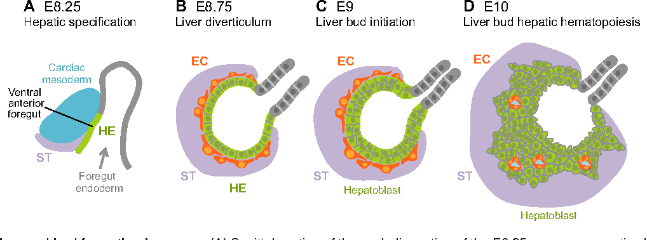

Haemopoiesis
- Earliest blood source: mesoderm of the yolk sac → blood islands → primitive erythrocytes (nucleated, synthesise haemoglobin)
- Stem cells from blood islands seed the liver and proliferate
- Liver produces adult-type RBCs, granulocytes, and platelets between 9th and 24th weeks
- With ossification and bone marrow development, liver haemopoiesis shuts down before birth
- The potential for hepatic haemopoiesis persists into adult life — expressed in extramedullary haemopoiesis when bone marrow fails (myelofibrosis, thalassaemia major, etc.)

Lobar Asymmetry & Arterial Changes
- Initially: right lobe is smaller than left lobe
- Between birth and adulthood: right lobe grows at the expense of the left, which undergoes peripheral degeneration
- This shift is accompanied by arterial remodelling:
  - In newborns: hepatic artery is the largest branch of the celiac trunk
  - In adults: splenic artery is larger than the hepatic artery
- The liver mass reduces and shifts rightward → hepatic artery and celiac trunk adopt a left-to-right orientation

Ventral Mesentery Derivatives
The ventral mesentery (ventral mesogastrium) produces:
Structure | From
Falciform ligament | Ventral abdominal wall to liver; hosts left umbilical vein at free border
Lesser omentum | Gastrohepatic ligament + hepatoduodenal ligament
Hepatoduodenal ligament | Envelops the portal triad (portal vein, hepatic artery, bile duct)

Mesenchymal origin of liver stroma:
- Future hepatic stroma, haemopoietic Kupffer cells, and vessels are all of mesenchymal origin
- Only hepatocytes and biliary epithelium are endodermal

Molecular Basis
Hepatic specification from foregut endoderm:
- FGF1/2 from cardiac mesoderm — the first and most critical hepatic inducing signal; FGF signalling from the developing heart induces hepatic fate in adjacent foregut endoderm
- BMP2/4 from septum transversum mesenchyme — acts synergistically with FGF to specify hepatic endoderm; BMP alone is insufficient
- FOXA1/2 (HNF3α/β) — pioneer transcription factors; open compacted chromatin at hepatic gene loci, making the foregut endoderm "competent" to respond to FGF/BMP signals before specification occurs
- GATA4/6 — co-operate with FOXA factors in establishing hepatic competence

Hepatocyte vs. biliary fate decision:
- Notch signalling (via Jagged1/Notch2) — drives biliary epithelial cell (cholangiocyte) fate; Jagged1 mutations → Alagille syndrome (paucity of intrahepatic bile ducts)
- TGF-β — promotes biliary differentiation in periportal hepatoblasts
- SOX9 — expressed in ductal plate cells; marks biliary progenitors; mutations cause various ductal plate malformation syndromes
- YAP (Hippo pathway effector) — controls liver size; YAP activation drives hepatocyte proliferation; critical for the massive growth of the fetal liver (10% of body volume at 9 weeks)

Haemopoiesis:
- SCF/c-Kit, CXCL12/CXCR4 — govern homing and expansion of haemopoietic stem cells in the fetal liver
- EPO (Erythropoietin) — drives fetal hepatic erythropoiesis; EPO is produced by the fetal liver (not kidney, as in adults) until late gestation

Clinical Correlations

Biliary Atresia
- Progressive inflammatory obliteration of the extrahepatic bile ducts; most common cause of neonatal cholestasis and the most common indication for paediatric liver transplantation
- Not caused by failure of recanalization — this is explicitly stated (Skandalakis); likely an immune-mediated destruction post-normal formation, possibly triggered by perinatal viral infection (Reovirus 3, CMV) in genetically susceptible individuals
- Presents: conjugated jaundice beyond 2 weeks, pale stools, dark urine, hepatomegaly
- Diagnosis: HIDA scan (no excretion into gut) + liver biopsy (bile duct proliferation, fibrosis) + intraoperative cholangiogram
- Treatment: Kasai portoenterostomy (ideally before 60 days) → ~50% achieve bile drainage; liver transplant for failures

Alagille Syndrome
- JAG1 mutations (Jagged1, Notch ligand) → failure of biliary differentiation → paucity of intrahepatic bile ducts
- Features: cholestasis, peripheral pulmonary stenosis, butterfly vertebrae, posterior embryotoxon (eye), characteristic facies
- Autosomal dominant; 94% penetrance but variable expressivity
- Directly reflects failure of Notch-mediated cholangiocyte specification

Extramedullary Haemopoiesis
- Hepatic haemopoiesis (9th–24th week) can be reactivated in adults when bone marrow fails
- Seen in: myelofibrosis, severe haemolytic anaemias (thalassaemia major, sickle cell), bone marrow infiltration
- Manifests as hepatosplenomegaly; rarely causes mass lesions

Hepatoblastoma
- Most common primary liver malignancy in children (<5 years)
- Recapitulates fetal hepatoblast differentiation — contains both hepatocytic and biliary elements
- Associated with Beckwith-Wiedemann syndrome (IGF2 overexpression, 11p15 imprinting defect) and familial adenomatous polyposis (APC mutation — Wnt pathway)
- AFP markedly elevated — reflects fetal liver protein expression

Congenital Portosystemic Shunts (Abernethy Malformation)
- Failure of normal portal venous development → portal blood shunted directly into systemic circulation
- Type 1 (complete): no intrahepatic portal flow → liver hypoplasia; associated with cardiac anomalies, biliary atresia
- Type 2 (partial): side-to-side shunt; some intrahepatic flow preserved
- Can cause hepatic encephalopathy, pulmonary hypertension, hepatopulmonary syndrome

Riedel's Lobe
- Tongue-like inferior extension of the right lobe — a normal variant, not pathological
- Reflects asymmetric right lobe growth that continues postnatally; more common in women
- Can be mistaken for hepatomegaly or a right upper quadrant mass

Key Points to Remember
- Hepatic primordium = Day 22; hepatic diverticulum growing into transverse septum = Day 24 — differentiation begins before the primordium is recognisable
- Human endodermal invasion is by individual cell migration, not cords — unique among vertebrates
- FGF (from heart) + BMP (from septum transversum) = the two essential hepatic induction signals; FOXA1/2 establishes competence before induction
- Intrahepatic bile ducts differentiate from hepatocytes and grow hilum → periphery; not by extension of extrahepatic ducts
- Biliary atresia is not a recanalization failure — it is post-formational inflammatory destruction
- Left umbilical vein persists → round ligament; right regresses at 6th week
- Liver haemopoiesis: 9th–24th week; EPO produced by fetal liver (not kidney)
- At 9 weeks: liver = 10% body volume (haemopoiesis + multiple sinusoids); at birth = 5% body weight
- Right lobe is initially smaller than left; reverses after birth
- Hepatic artery is largest celiac branch in newborns; splenic artery becomes larger in adults

